**Adjust MySQL to allow for larger packet size**

MAX_ALLOWED_PACKET must be increased to handle large data grabs from REST API

Required for each installation of MySQL or WordPress debug log will grow exponentially and effectively disable the website

1) open terminal

2) ssh root@YOURIP

3) enter root password

4) nano /etc/mysql/my.cnf

- or –

vi /etc/mysql/my.cnf

5) add the line: max_allowed_packet=1000M (obviously adjust size for whatever you need) under the [MYSQLD] section.

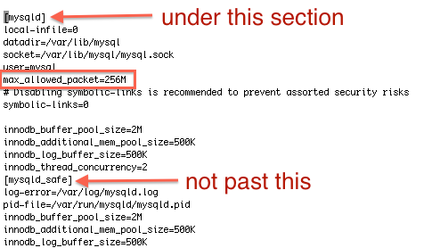

6) nano: Control + O (save) then ENTER (confirm) then Control + X (exit file)

- or -

vi: ESC then :wq then ENTER

7) service mysqld restart

8) You can check the change in the variables section on phpmyadmin